INDIRECT COSTS
Additional Exercises

Reference info:

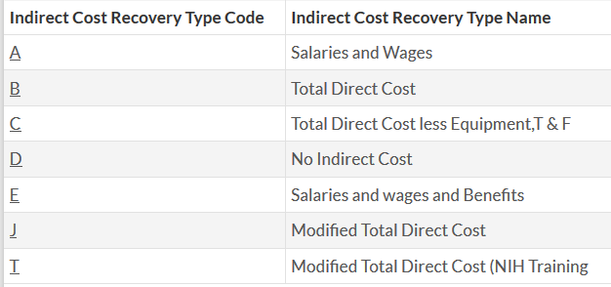

Formula to convert TC to TDC:

TC / (1 – TC) = TDC
BUDGETING
4. Modified Total Direct Cost (MTDC) - Using a 60% indirect rate with a MTDC base (KFS type J), calculate the total cost of this award:

Budget Category | Direct | F&A | Total
ACAD SAL REGULAR FACULTY | 43,350
ACAD SAL OTHER ACADEMICS | 2,750
GENERAL ASSISTANCE | 289,500
BENEFITS | 91,600
SUBCONTRACT (1) | 122,150
SUPPLIES AND EXPENSE | 518,900
TRAVEL | 13,050
EQUIPMENT AND FACILITIES | 9,500
TOTAL | 1,090,800

5. Total Direct Cost (TDC) - Using a 25% indirect rate with a TDC base (KFS type B), calculate the total cost of this award:

Budget Category | Direct | F&A | Total
ACAD SAL OTHER ACADEMICS | 100,500
BENEFITS | 34,800
SUPPLIES AND EXPENSE | 800
TRAVEL | 1,400
TOTAL | 137,500

6. Total Cost (TC) - Using a 20% indirect rate with a TC base, calculate the total cost of this award. What is the effective F&A rate to be used on the ledger?

Budget Category | Direct | F&A | Total
GENERAL ASSISTANCE | 62,600
BENEFITS | 12,500
SUBCONTRACT (1) | 8,400
SUPPLIES AND EXPENSE | 15,250
TRAVEL | 500
TOTAL | 102,250

REBUDGETING
4. Your supplies budget is fully spent, but $2,700 of additional supplies are needed for the project. Using a 52% indirect rate with a Modified Total Direct Cost (MTDC) base, determine the new budget after moving $2,700 to supplies from benefits. Adjust indirect costs as needed.

Budget Category | Direct | F&A | Total
SALARIES | 62,600
BENEFITS | 15,500
SUBCONTRACTS | 8,300
SUPPLIES | 15,250
TRAVEL | 500
TOTAL DIRECT COSTS | 102,150
INDIRECT COSTS | 53,118
TOTAL | 155,268

5. Your supplies budget is fully spent, but $3,500 of additional supplies are needed for the project. Using a 19% indirect rate with a Total Direct Cost (TDC) base, determine the new budget after moving $3,500 from equipment to supplies. Adjust indirect costs as needed.

Budget Category | Direct | F&A | Total
GENERAL ASSISTANCE | 10,350
BENEFITS | 1,525
SUPPLIES AND EXPENSES | 225
EQUIPMENT | 50,400
TOTAL DIRECT COSTS | 62,500
INDIRECT COSTS | 11,875
TOTAL | 74,375

6. Your equipment budget is fully spent, but $5,500 of additional equipment is needed for the project. Using a 60.0% indirect rate with a Modified Total Direct Cost (MTDC) base, determine the new budget after moving $5,500 to equipment from benefits. Adjust indirect costs as needed.

Budget Category | Direct | F&A | Total
GENERAL ASSISTANCE | 179,500
BENEFITS | 63,700
TRAVEL | 6,900
EQUIPMENT | 27,400
TOTAL DIRECT COSTS | 277,500
INDIRECT COSTS | 128,802
TOTAL | 406,302

